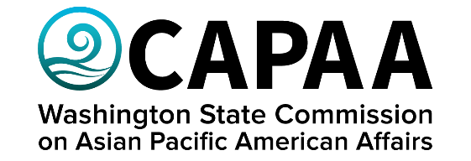

Public Board Meeting Agenda
Saturday, March 23rd 2024, 10am-11am
Virtual via Zoom

AGENDA
Time | Business Item | Speaker
10:00 AM | Call to Order | Chair Faitalia
10:01 | Approval of Agenda  - Action to approve | Chair Faitalia
10:02 | Approval of Minutes  - Action to approve | Chair Faitalia
10:03 | Public Comment
10:13 | Workgroup Report backs | Sameth Mell – Digital Equity Forum  Harold Taniguchi- Active Transportation Safety Advisory Council
10:24 | Budget overview | Executive Director Hasegawa
10:29 | Legislative Session Recap | Project Manager Yodkerepauprai
10:34 | Civic engagement contract with Kaya Strategik | Executive Director Hasegawa
10:44 | Golden Celebration Overview | Executive Director Hasegawa
10:59 | Good of the Order | Chair Faitalia
11:00 | Adjournment | Chair Faitalia

